School in motion
Welcome back students and teachers. I hope you all had a great holiday and New Year. Well to kick off the New year we are having a field and tag day; it should be a fun time. Going into sports news, there was a Chargers game on December 20, 2014. It was a close game but in the end Chargers won against the 49ers. Go Chargers! The final score was 38-30 it was a good win. On December 28,2014 the chargers played against the Chiefs. In the end they lost by 7 points at 7-14. The Chargers ended the season then and won't be playing in the playoffs.

Reminders
It is getting a little warmer so remember to follow the dress code.
It is time to take a stand and keep our school safe. Speak up and become a friend, not a bully.

What to do?
No school on January 16th, it's Professional Learning Day.
No school on January 19th, it's Martin Luther King's birthday.

Funny jokes
- Teacher: "Whoever answers my next question can go home. *One boy throws his bag out the window. Teacher: "Who just threw that?" Boy: "Me. I'm going home now."

Fun facts
Albert Einstein never wore socks.

Hill creek
Solar powering healthy minds for a brighter future
January 2015

Events Coming To You
Welcome back Students, Teachers, and Staff. The Winter Wonderland dance was a spectacular event. Going into upcoming events at our school, there is going to be an ACE Award Assembly on January 23rd, so be on your Bulldog Best. There is going to be a field day coming up as well, so be a good citizen in our school and our community.

Insider outsider
The student we would like to recognize for community involvement for this month is Trevor Margers. He is a good citizen in our school because during the year he saves up all of his money so others who are less privileged can eat during the holidays. He participates in Santee Santa's every year by buying canned food for people that don't have any food. He has been doing this for a long time. So thank you for helping our community Trevor.

What to do?
I am here to solve all your problems and help you through different things.
- People are bullying me non-stop. What should I do?
Well what you should do is tell someone and seek help from a trusted adult. You could also tell them how you feel and that they should stop. " Actions speak louder than words"
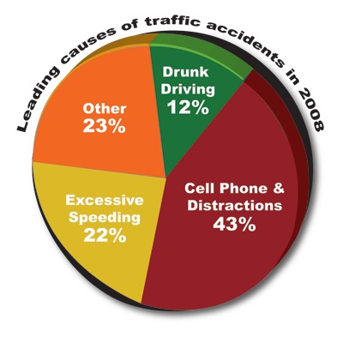
- I can't keep my grades up. What should I do?

It is up to us to stop it!
Our school should be safe! It is up to us to stop negative activity in our school and our community each day. One large issue right now in our community, state, and city is texting and driving. Texting and driving has been a large problem for a few years since technology has blossomed into what we have now. In 2011 23% of all crashes were caused by cell phones also texting and driving make it 23x more possible for a car crash to occur. Also texting and driving is deadly. Not only could you kill yourself, but you could harm others. Think about others and yourself, and don't text and drive.

Well, you should study and find a method that works for you. If you still can't keep up your grades then find something that motivates you. Another way to keep up your grades is to do extra credit and to do your homework. "Push yourself because no one is going to do it for you."
- There is a girl/boy that has bullied me in the past and now he/she wants to become my friend. What should I do?
- You should give the person a second chance and try to see past their past actions. If they prove to not be worthy of your trust or not worthy to be your friend then don't be their friend. You shouldn't open up to them until you know that they are a true friend and that they have changed their ways. "Take a chance because you will never know how perfect something is until you try it."
LEAVE YOUR QUESTIONS IN MS. KNUDSON'S ROOM

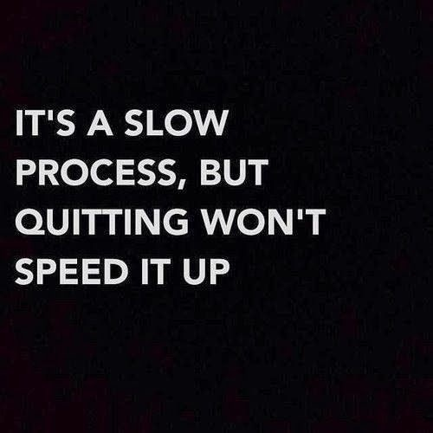
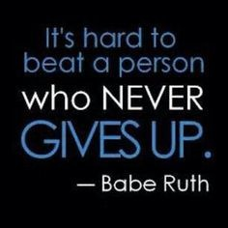
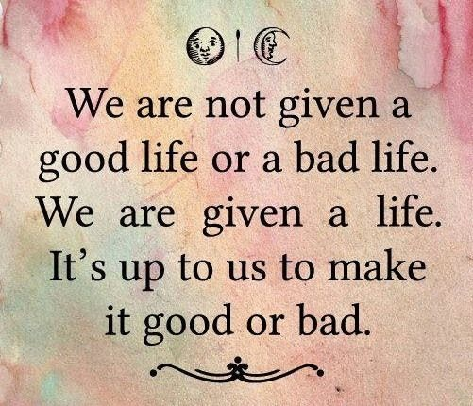
Inspiration

